SnapBuy AI — Project Guide
Table of Contents

Oct 22, 2026 · Live version of this guide: Claude Docs
SnapBuy AI is a free website that helps people in India shop smarter. You show it a photo or type what you want, and it finds that product in online stores and tells you where it is cheapest.
- Try it: snapbuy-ai.vercel.app
- Code: github.com/itskunalkanaujiya/SnapBuyAI
No sign-up is needed. Anything you save (wishlist, recent searches, your colours, watched prices) stays in your own browser.

What you can do with it
The home page has one search box and a grid of 10 tools. Each tool does one job.
Tool | What you give it | What you get back
Search by photo | A photo of any product | The same product in many stores, cheapest first
Describe it | A sentence, typed or spoken (“HP laptop, 8GB RAM, under 50k”) | Products that match what you asked for
Find the outfit | A photo of a person | Every item they are wearing, each with shopping links
Rate my outfit | A photo of your outfit | A score out of 10 and tips to improve it
Colours that suit me | A selfie | The colours that look best on you
Plan a look on a budget | An occasion and a budget (“wedding, ₹5,000”) | A full outfit that fits the budget
Find a gift | Who it’s for, what they like, a budget | Six gift ideas with shopping links
Shop my list | A photo of a shopping list, or a typed one | Every item found, with a total cost
Shop a room | A photo of a room | The furniture and decor in it, with links
Price watch | Tap the bell on any product | An alert when its price drops
Some extras work on every result:
- Compare: tick 2 or 3 products to see them side by side, with the best pick.
- Ask AI: chat about the results (“which one is best for gaming?”).
- Complete the look: see what goes well with a product.
- Try on: see clothes, glasses or a watch on your own photo.
- Deal check: each price is marked as a great deal, a fair price or expensive, and fake “70% off” discounts are flagged.

How it works, in simple words
Every tool follows the same four steps.
- You ask. You give the website a photo or a sentence.
- AI understands it. An AI model looks at the photo or reads the sentence and works out what to search for. For example, from an outfit photo it finds “red silk saree” and “gold jhumka earrings”.
- We search the stores. The website searches Google Shopping and Google Lens, which cover Amazon, Flipkart, Myntra, AJIO, Meesho and many more.
- We sort and show the results. Another AI compares each product’s picture with yours and keeps the closest ones. Prices are checked, and the results appear on screen one by one, as soon as each is ready.
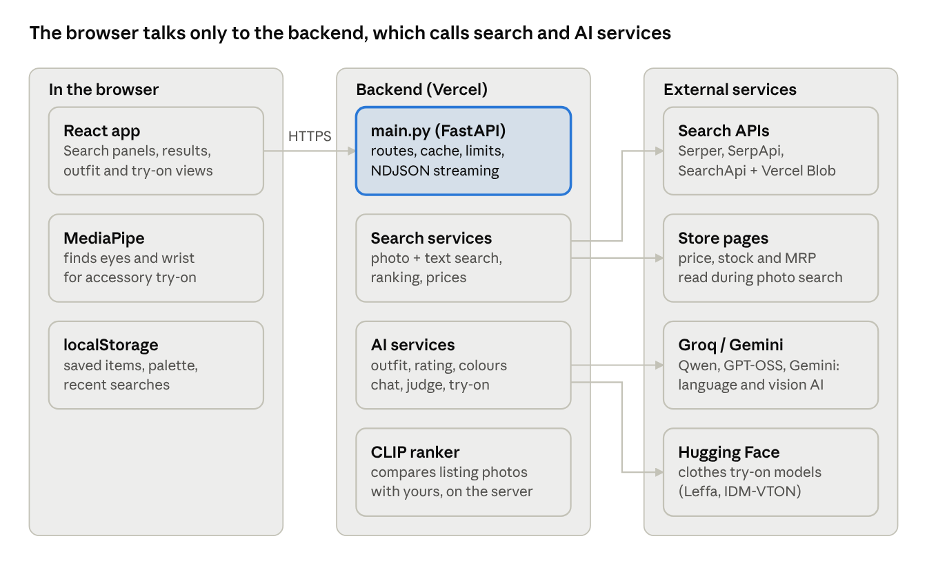
How SnapBuy AI works: the browser, the server, and the outside services it uses
The project has two parts that talk to each other:
- Frontend (the website you see): buttons, search box, results. It runs in your browser.
- Backend (the server): does the heavy work. It calls the AI models and the store searches, and keeps the secret keys safe.

What it is built with
Part | Tool used | Why
Website | React + Vite | Builds a fast, modern web page
Server | Python + FastAPI | Handles requests and runs the AI steps
Understanding photos | Google Gemini (main), Groq (backup) | AI that can look at a photo and describe what’s in it
Understanding text | Groq (Qwen and GPT-OSS models) | AI that reads sentences, including Hindi and Hinglish
Comparing pictures | CLIP | Scores how alike two photos look, from 0 to 1
Store search | Serper, SerpApi, SearchApi | Gives access to Google Shopping and Google Lens
Reading store pages | BeautifulSoup | Reads the price, stock and MRP from a store’s page
Clothes try-on | Hugging Face | Free AI that puts a garment on your photo
Glasses and watch try-on | MediaPipe | Finds your eyes or wrist in a photo, inside the browser
Hosting | Vercel | Puts the website and server online
Testing | pytest | 280 automatic checks that the code works
Everything runs on free plans of these services.

Where things are in the code
The code has two main folders, one for each part.
SnapBuyAI/
├── backend/ The server (Python)
│ ├── main.py The front door: every request arrives here
│ ├── image_shopping_service.py Search by photo
│ ├── text_shopping_service.py Search by sentence
│ ├── outfit_service.py Find the outfit, Complete the look
│ ├── style_service.py Rate my outfit, Colours that suit me
│ ├── planner_service.py Plan a look on a budget
│ ├── gift_service.py Find a gift
│ ├── list_service.py Shop my list
│ ├── room_service.py Shop a room
│ ├── price_watch_service.py Price watch
│ ├── assistant_service.py Ask AI chat and Compare
│ ├── tryon_service.py Try on
│ └── tests/ The 280 automatic checks
│
├── frontend/ The website (React)
│ └── src/
│ ├── App.jsx The main page: decides what to show
│ ├── components/ The pieces you see (search box, cards, tool pages)
│ └── lib/ The logic behind them (calling the server, deal scores)
│
└── docs/ This guide
A simple rule: one feature, one backend file. To change how gifts work, open gift_service.py.

How each feature works
Search by photo. Your photo goes to Google Lens, which finds similar products online. CLIP then compares each result’s picture with yours and labels it “Very close”, “Similar” or “Related”. The website also opens each store page to read the real price.
Describe it. The website reads your sentence and pulls out the important parts: the product, brand, budget and features. It understands Hinglish too (“50k ke andar”). Products over your budget are never shown.
Find the outfit. AI looks at the photo from head to toe and lists up to 8 items, with a box around each one. Each item is searched separately, and results are sorted by how much they look like that item in the photo. “Exact match” runs a full photo search on just one item.
Rate my outfit. AI scores four things (colours, fit, styling, occasion) and gives an overall score out of 10. It then suggests 2–3 items to improve the look. A second AI, the “listing judge”, checks that the shopping results are really the suggested item.
Colours that suit me. AI looks at your skin, hair and eye colour and gives you a palette. Products in those colours get a “Suits you” label. Only the palette is saved, never your selfie.
Plan a look on a budget. AI plans 3–5 pieces for the occasion and splits the budget between them. If the total goes over budget, pieces are swapped for cheaper options, starting where the most can be saved, until it fits.
Find a gift. AI suggests six different gift ideas based on the person and what they like. Each idea is searched, and anything far over the budget is removed.
Shop my list. AI reads each line of your list, even handwriting, and searches for every item. It picks a sensibly priced option for each and adds up the total.
Shop a room. Works like Find the outfit, but for furniture, lamps, rugs and decor.
Price watch. Watched products are saved in your browser. Every 12 hours, when you open the website, their prices are checked again. If a price has dropped, you see a banner and a notification.
Deal check. Each price is compared with the typical price of similar products. If a product claims a big discount but costs the same as everywhere else, it is marked “Discount looks inflated”.

Run it on your computer
You need Python 3.13, Node.js 20 or newer, and at least one search key (Serper or SerpApi). Open two terminals.
Terminal 1 — the server:
cd backend
python -m venv ../myvenv
../myvenv/Scripts/activate # Mac/Linux: source ../myvenv/bin/activate
pip install -r requirements.txt
cp .env.example .env # then add your own keys to .env
uvicorn main:app --host 127.0.0.1 --port 8000
Terminal 2 — the website:
cd frontend
npm install
npm run dev
Then open http://127.0.0.1:5173 in your browser.
Which keys turn on which features (all go in backend/.env):
Key | Turns on
SERPER_API_KEY or SERPAPI_API_KEY | Basic search (required)
SEARCHAPI_API_KEY + BLOB_READ_WRITE_TOKEN | Faster photo search
GROQ_API_KEY | All AI features
GEMINI_API_KEY | Faster, more accurate photo understanding
HF_TOKEN | Clothes try-on
Never share these keys or put them in the code. The .env file is ignored by git, so it never gets uploaded.

Testing and putting it online
Before every update, run three checks:
Check | Command | What it proves
Server tests | cd backend && pytest -q | All 280 checks pass
Code style | cd frontend && npx eslint src | No mistakes in the website code
Build | cd frontend && npx vite build | The website builds without errors
The tests never use real services or spend any credits; fake versions of the AI and search services are used instead.
To put a new version online, push the code to the main branch on GitHub. Vercel then updates both the website and the server automatically, in about two minutes. Press Ctrl + Shift + R on the website to see the new version.
Part | Address
Website | snapbuy-ai.vercel.app
Server | snapbuy-ai-api.vercel.app
The secret keys are stored on Vercel as encrypted settings, not in the code.

Common problems
What you see | Why | What to do
“Can’t reach the SnapBuy server” | The server isn’t running | Start it (Terminal 1 above)
“The AI is busy right now” | The free AI limit for this minute is used up | Wait a minute and try again
“Try-on is busy” | The free try-on quota for today is used up | Try again tomorrow
“Limit reached” | Each visitor gets 10 searches every 10 minutes | Wait a few minutes
The first search is slow | The server was asleep and is starting up | Normal; the next ones are fast
Changes don’t show after an update | The browser kept the old version | Press Ctrl + Shift + R

Words explained
Word | Meaning
AI model | A program trained to understand photos or text
Google Lens | Google’s “search with a picture”
Google Shopping | Google’s list of products and prices from many stores
CLIP | An AI that scores how similar two pictures look
Gemini, Groq | Services that run AI models; SnapBuy uses their free plans
Listing judge | A second AI that double-checks search results are the right item
API | The way the website and the server talk to each other
API key | A secret password that lets the server use an outside service
Frontend / Backend | The website you see / the server doing the work behind it
Streaming | Showing results one by one as they are ready, instead of all at the end
MRP | Maximum Retail Price, used to check if a discount is real
Vercel | The service that hosts the website online

For developers: server address list
Every request goes to the server address above (or http://127.0.0.1:8000 on your computer). A full, clickable list is at /docs on the server. Addresses ending in /stream send results one by one as they’re ready.
What it does | Address
Search by photo | POST /api/v1/products/search-by-image/stream
Search by sentence | POST /api/v1/products/search-by-text/stream
Find the outfit | POST /api/v1/outfit/stream
Complete the look | POST /api/v1/look/stream
Rate my outfit | POST /api/v1/style/rate/stream
Colours that suit me | POST /api/v1/style/colours
Plan a look | POST /api/v1/plan/stream
Find a gift | POST /api/v1/gifts/stream
Shop my list | POST /api/v1/list/stream
Shop a room | POST /api/v1/room/stream
Price watch | POST /api/v1/prices/check
Compare | POST /api/v1/compare
Ask AI | POST /api/v1/assistant
Clothes try-on | POST /api/v1/tryon
Searches left | GET /api/v1/usage

